REGALIS WORKSPACE
Reports & Analysis — Complete Feature Specification
A redesign of the reporting section: charts first, exports second, and every figure counted on the server
Module: Reports & Analysis (Admin Portal)
Menu: ANALYTICS -> Reports & Analysis
Replaces: the existing Report and Analysis page and Report Library
Document Version: 1.0 — October 2026

How To Use This Document
This document is self-contained. It describes ONE part of the admin portal — Reports & Analysis — end to end: why it is being rebuilt, what every screen looks like, what every number on it means, where that number comes from, and how the exports and scheduled emails behave. It can be handed to Claude on its own, together with the existing Regalis codebase.
- Section 1 explains what is wrong with the page today and what the new one must do.
- Section 2 lists the three screens and the routes they live on.
- Sections 3, 4 and 5 show every screen with a design reference image, block by block, with the exact text and behaviour of each control.
- Section 6 is the full catalogue of reports, grouped, with what each one contains.
- Section 7 has the five flow charts: opening the page, running a report, exporting, scheduled emails, and how a figure is calculated.
- Section 8 is the rules every number must follow. Read this section twice — most reporting bugs come from here.
- Section 9 gives the data model, the formulas and the API.
- Section 10 covers the charts themselves: types, colours and interaction. Section 11 exports, Section 12 schedules, Section 13 permissions.
- Sections 14 to 17 cover performance, empty and error states, open items and the one-paragraph summary.
NOTE: Build this inside the existing app. Reuse the current admin layout, sidebar, table component, filter controls, buttons and colour variables. Do not create a new design system and do not add a charting theme of your own — the colours are fixed in Section 10.
NOTE: The live UI design for every screen is on the Regalis Reports & Analysis design canvas. The images in this document are taken from it; open the canvas to check exact spacing, colours and wording.

1. Why This Page Is Being Rebuilt
The reporting section exists today, but it is not usable as a management tool. Four things are wrong with it.
What is wrong today | What it causes
The page shows four plain number cards and one small revenue line. Everything else on it is an empty panel with a placeholder. | An admin cannot answer any real question from this page — not which space earns the most, not when the building is busy, not who owes money. They go back to exporting a spreadsheet.
The Report Library is a long wall of identical cards with no grouping, no search and no favourites. | Finding the right report takes longer than reading it. The reports that matter every week are buried next to ones nobody has ever opened.
Opening a report gives a bare table. No totals, no shape, no chart. | The admin has to export to Excel to get a total. The screen is only a preview of a download.
Nothing is scheduled. Every report is pulled by hand. | The GST summary and the overdue list are remembered or forgotten by a person.

1.1 What the New Page Must Do
- Answer questions without an export. Revenue, occupancy, what is booked, when the space is busy, who owes money, and who the biggest customers are must all be visible as charts on one screen.
- Always compare. Every headline figure is shown against the period before it, so a number has a direction and not just a value.
- Count on the server. Every total is calculated across all matching rows in the database, never from the rows loaded on screen. This is the single most important rule in this document.
- Make reports findable. Grouped, searchable, with favourites and a recently used list.
- Make a report a page, not a table. Filters, three or four summary figures, a chart, then the table.
- Let reports send themselves. Any report can be emailed daily, weekly or monthly as Excel or PDF.
NOTE: Nothing in this document changes how bookings, invoices or payments are recorded. Reports & Analysis only reads data. It must never write to an operational table — the only things it writes are saved filters, favourites, schedules and the export log.

2. The Three Screens
The whole module is three screens. Everything else is a variation of the second one.
# | Screen | Route | What it is for
1 | Reports & Analysis — overview | /admin/reports | The dashboard. Charts only. The first thing an admin sees when they click Reports & Analysis
2 | A single report | /admin/reports/:reportKey | One report, run with filters, with its own summary figures, chart, table and export
3 | Report library | /admin/reports/library | The list of all available reports, grouped and searchable, plus the schedules

2.1 Where It Sits In The Menu
- Sidebar group ANALYTICS, single item Reports & Analysis, which is highlighted whenever any of the three screens is open.
- Under it, five sub-items: Overview, Revenue, Occupancy, Customers, Report library. The middle three are the overview screen scrolled to that group of charts, or a filtered library — either is acceptable, as long as the sub-item highlights.
- The old menu entries Report and Analysis and Report Library are removed and redirected to the new routes.

2.2 The Screens At A Glance
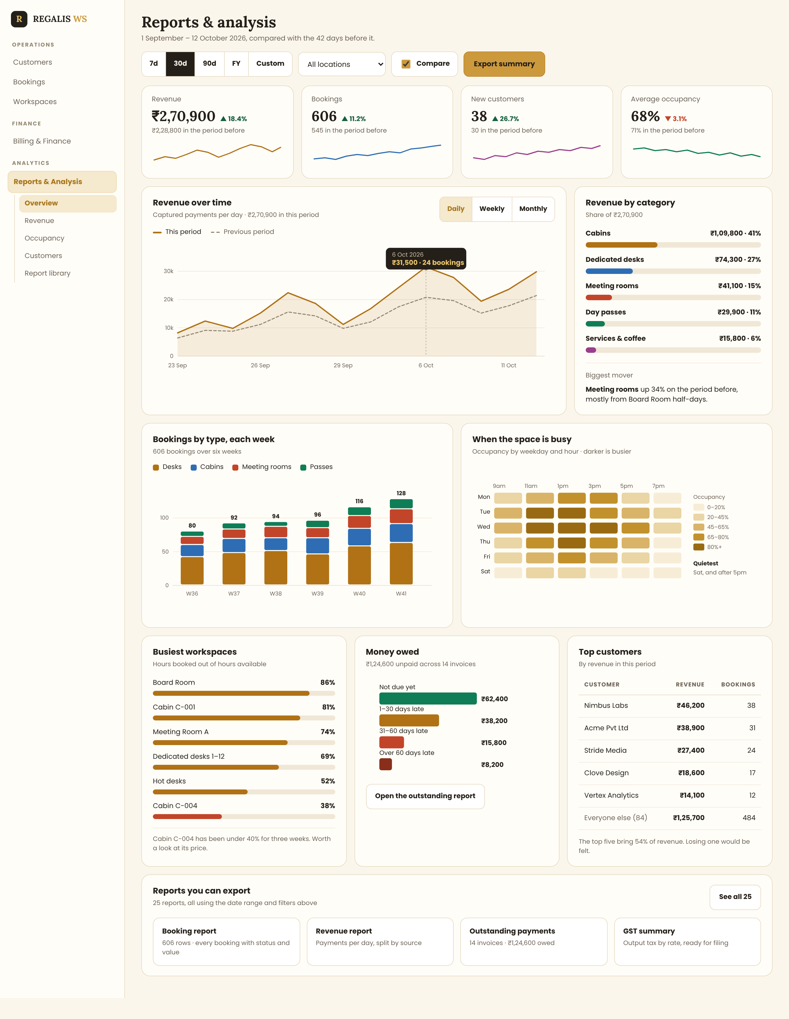
Screen 1 — the Reports & Analysis overview, full page
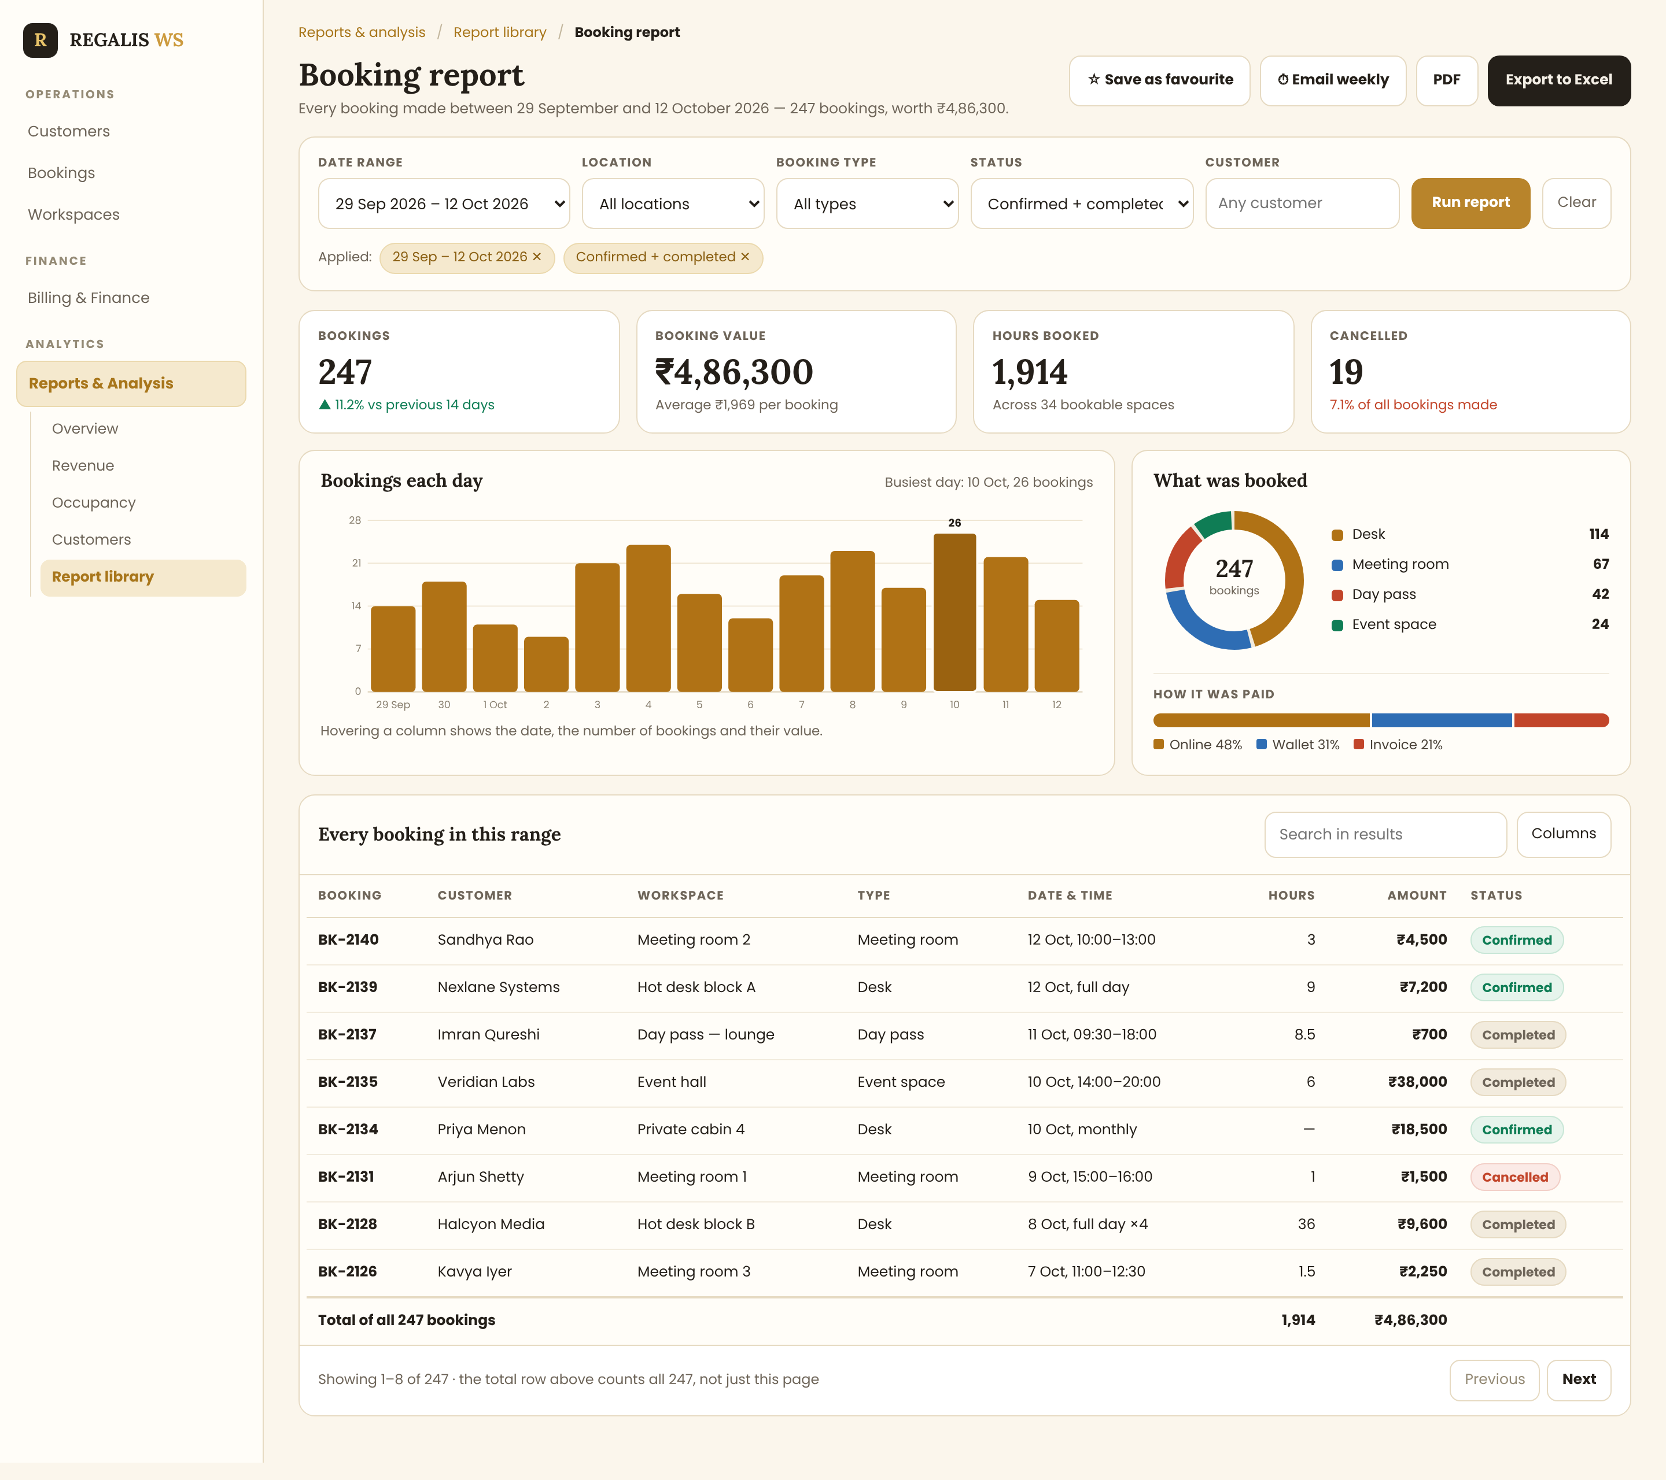
Screen 2 — a single report (Booking report)
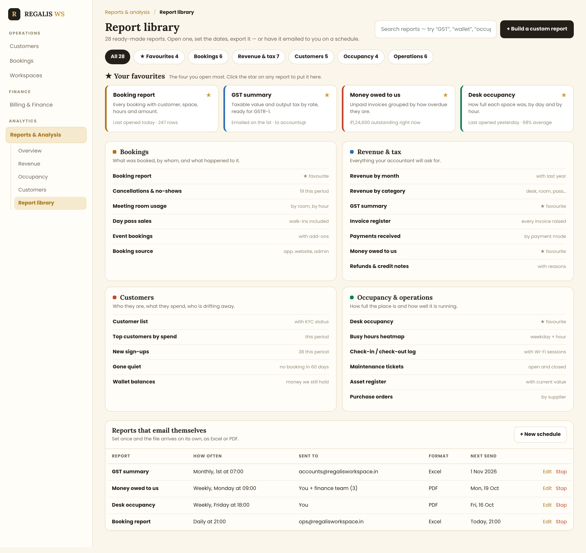
Screen 3 — the report library

3. Screen 1 — Reports & Analysis Overview
This is the dashboard. It has no tables of raw data except one small Top customers table at the bottom; everything else is a chart. It must load in one request and under two seconds.

3.1 The Header And The Date Range Bar
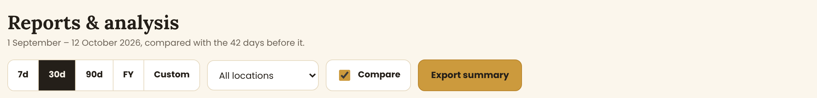
The page title, the period in words, and the controls that drive every chart below
Everything on this screen obeys these controls. Changing any of them reloads every card and chart on the page at once.
Control | Behaviour
Title and sub-line | "Reports & analysis", and under it the period written out in plain English: "1 September – 12 October 2026, compared with the 42 days before it." The sub-line is rewritten whenever the range changes
7d / 30d / 90d / FY / Custom | A segmented control. One is always selected (dark). FY means the Indian financial year, 1 April to 31 March. Custom opens a two-month date picker with a Apply and Cancel
Location | A dropdown listing every Regalis location plus "All locations". Default: All locations. If Regalis has only one location, hide this control
Compare | A checkbox, ticked by default. When ticked, every figure shows a change against the previous period of the same length and the revenue chart draws a dashed comparison line. When unticked, all the arrows and the dashed line disappear
Export summary | Downloads this whole screen as a PDF, exactly as it appears, with the date range printed on it
NOTE: The chosen range, location and Compare setting are remembered per admin. When they come back to the page tomorrow, it opens where they left it. Store this against the user, not in the browser.

3.2 The Four Headline Cards
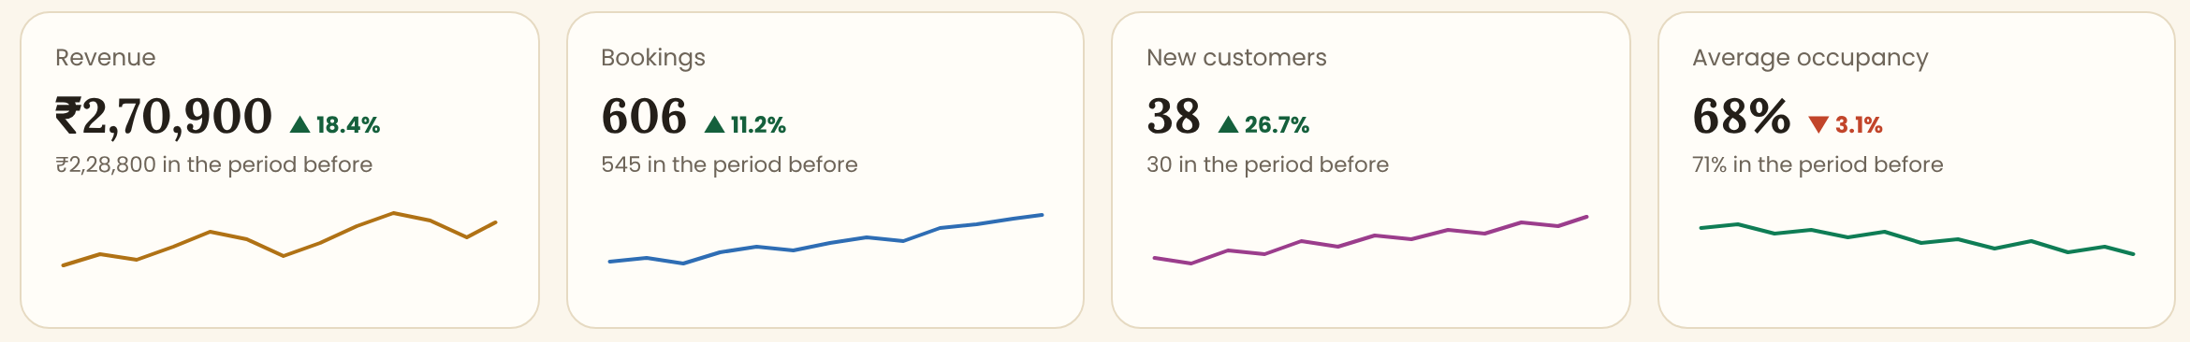
Four KPI cards, each with its own sparkline and its own comparison
Four cards, in this order, each with: a label, the big figure, the change against the previous period, the previous value in words, and a 14-point sparkline of the same measure over the selected range.
Card | The figure | The rule behind it
Revenue | Money actually received in the period | Sum of payments received, in IST, excluding refunds. NOT invoices raised — see Section 8.2
Bookings | Number of bookings whose start date falls in the period | Cancelled bookings are excluded from the count but counted in the Cancelled figure on the booking report
New customers | Customers who registered in the period | By registration date, not by first booking
Average occupancy | Hours booked divided by hours available, across the period | See the formula in Section 9.3. Shown as a whole percentage
- The change is green with an up triangle when the figure improved and red with a down triangle when it worsened. For every card here, up is good.
- If the previous period had a value of zero, show "no comparison" instead of a percentage. Never show infinity or 100% in that case.
- The sparkline has no axes, no labels and no grid. It is a shape, not a chart. Each card uses its own colour from the palette in Section 10.
- Each card is clickable and opens the matching report.

3.3 Revenue Over Time
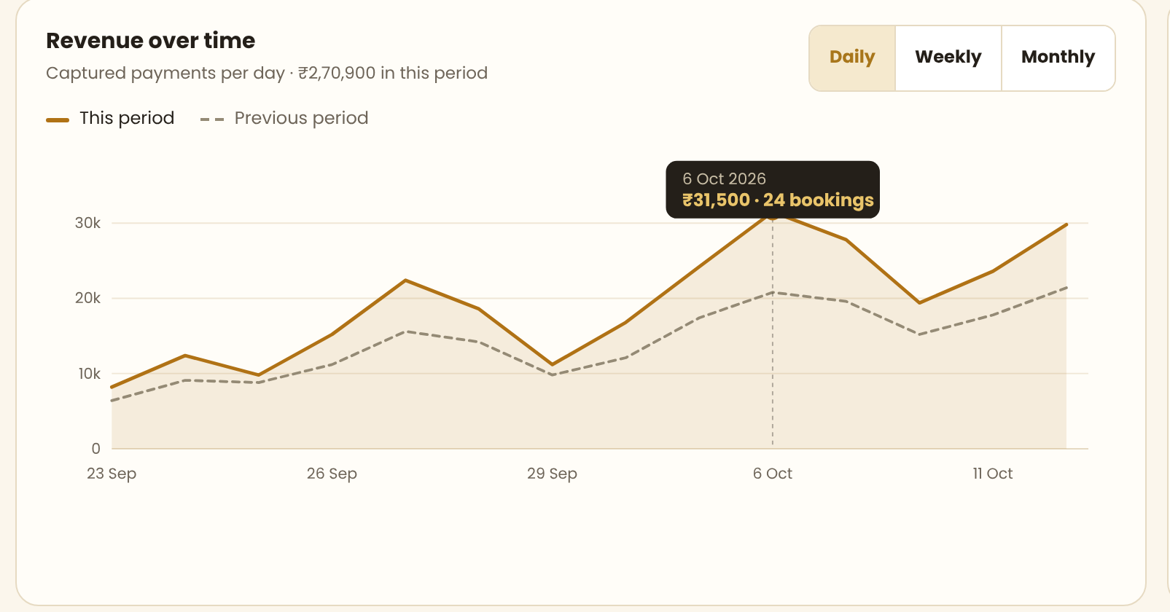
The main chart: revenue per day, with the previous period as a dashed line and a tooltip on hover
Element | Behaviour
The solid line and fill | Revenue captured per day, over the selected range. The area under it is the same colour at a light tint
The dashed grey line | The same measure for the previous period of the same length, drawn on the same dates so the two can be compared. Hidden when Compare is unticked
Daily / Weekly / Monthly | Changes the grouping. Daily is the default for ranges up to 60 days, Weekly up to 12 months, Monthly beyond that — but the admin can override
Hover | A vertical line follows the cursor and a dark tooltip shows the date, the revenue and the number of bookings on that day. The tooltip must appear anywhere on the plot, not only exactly on a point
The y axis | Money, shortened: 10k, 20k, 30k. Four gridlines, no more. The axis always starts at zero
Empty days | A day with no revenue is drawn as zero, not skipped. A gap in the line is a bug

3.4 Revenue By Category
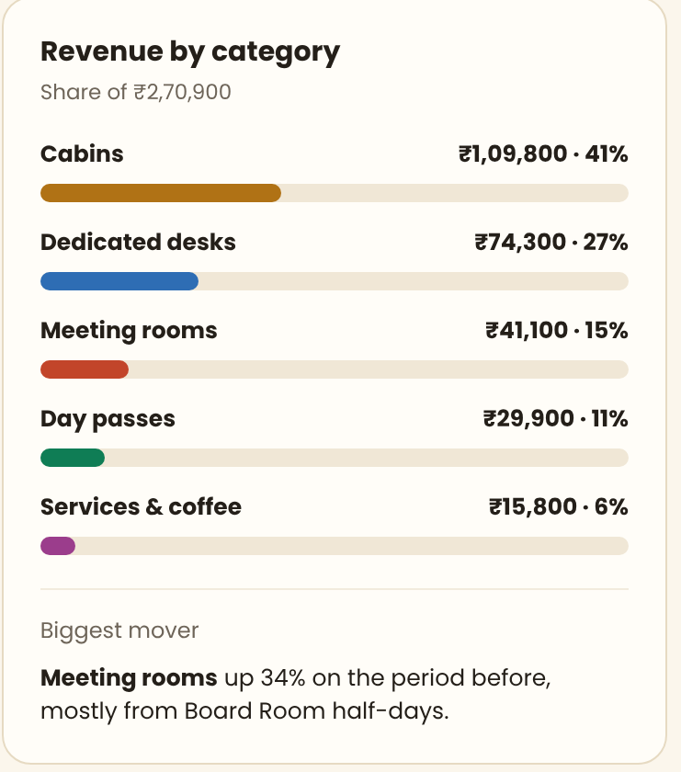
Where the money came from, as a share of the period total
- One bar per category, sorted highest first: Cabins, Dedicated desks, Meeting rooms, Day passes, Services & coffee. These come from the booking category, not from a hard-coded list — if Regalis adds a category it must appear here.
- Each row shows the name, the amount in rupees and the share as a percentage, then the bar. The bar track is always full width, so the lengths can be compared by eye.
- The percentages must add to 100. Round so that they do.
- Under the bars, a Biggest mover line: the category that changed most against the previous period, in one sentence. Calculate it; do not hard-code it.

3.5 Bookings By Type, Each Week
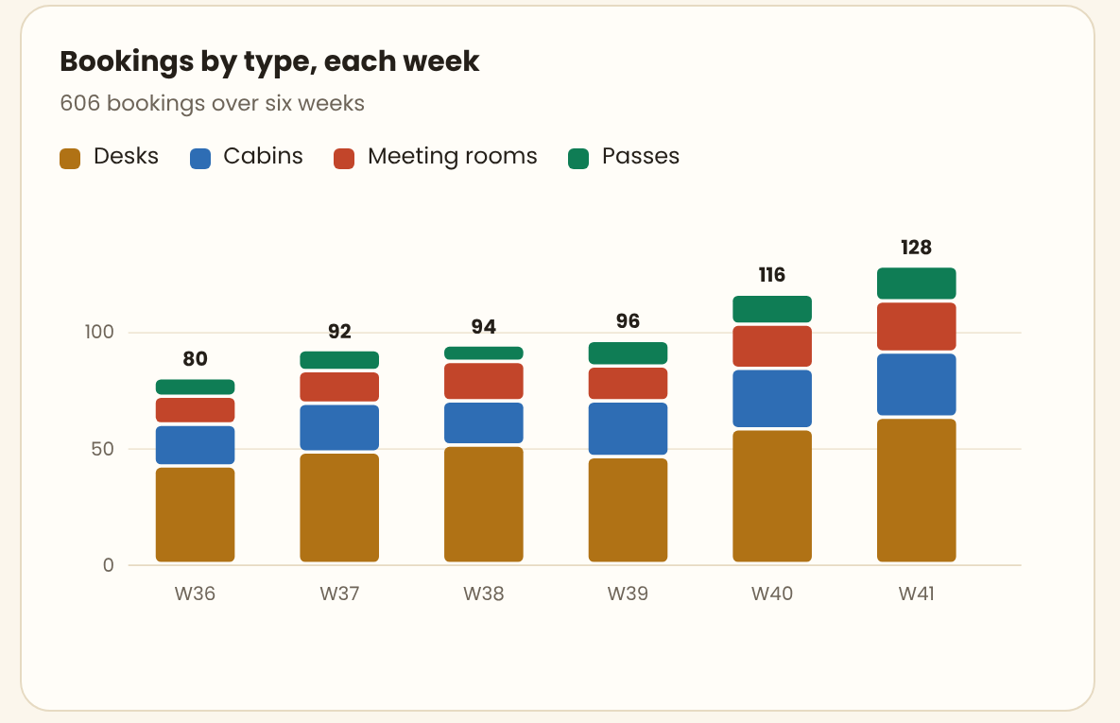
A stacked column per week, with the total printed above each column
- One stacked column per week in the range, each split into Desks, Cabins, Meeting rooms and Passes.
- The total of each column is printed above it so the overall trend is readable without adding the segments up.
- A legend sits above the chart with the four names and their colours. There is a 2px gap between the segments so they stay separate on a printed page.
- If the range is shorter than three weeks, group by day instead of by week and change the sub-line to match.

3.6 When The Space Is Busy
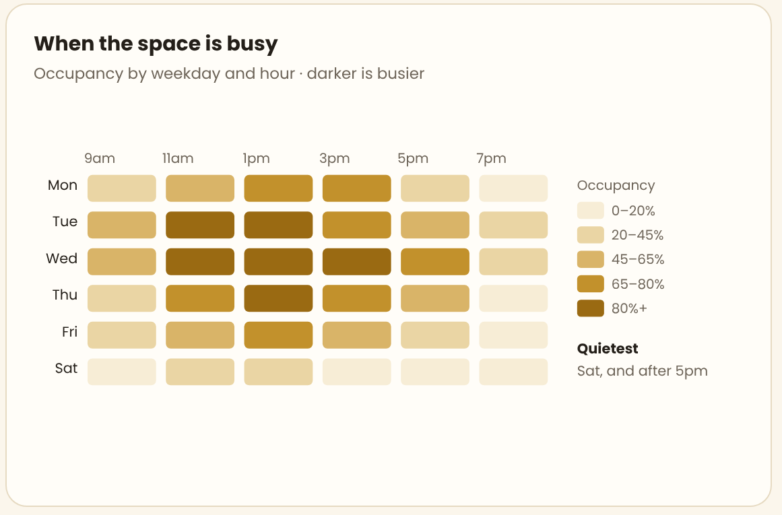
Occupancy by weekday and hour — the darker the cell, the busier the hour
- A grid of weekday (Mon to Sat, add Sun only if Regalis opens on Sunday) against hour, from 9am to 8pm.
- Each cell is shaded on a single-colour scale with five steps: 0–20%, 20–45%, 45–65%, 65–80%, 80%+. A legend naming all five steps sits to the right. Never use a rainbow or a red-to-green scale here.
- The percentage is seats occupied out of seats available in that hour, averaged across every matching weekday in the range.
- Hovering a cell shows the weekday, the hour, the exact percentage and the number of people.
- Under the legend, a Quietest line naming the slowest slot in one short sentence.

3.7 The Bottom Row
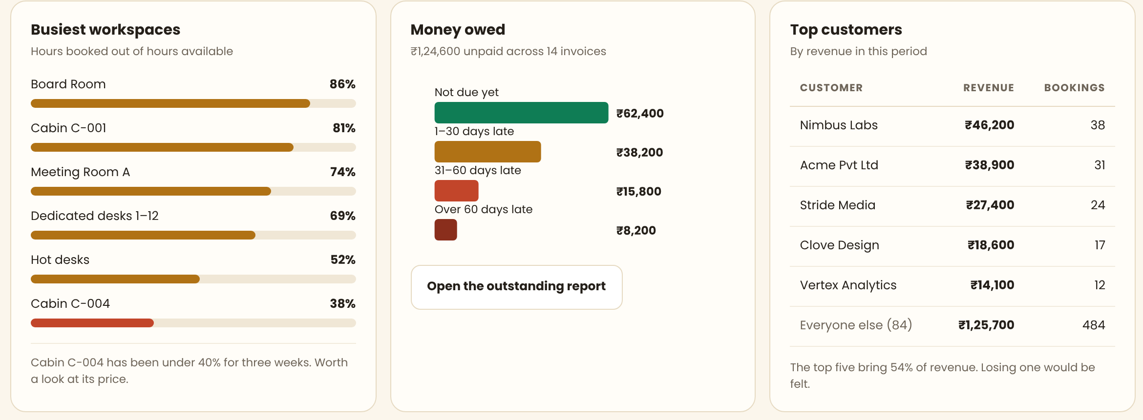
Busiest workspaces, money owed by age, and the top customers

Busiest workspaces
- One bar per bookable space, sorted busiest first, showing hours booked out of hours available as a percentage.
- Show the top six and a "See all" link. The colour of each bar follows the band it falls in — this is the only chart where colour carries a value rather than an identity.
- Under the bars, one sentence naming the space that has been under 40% for three weeks or more. Calculate it.

Money owed
- Four bars: Not due yet, 1–30 days late, 31–60 days late, Over 60 days late, with the amount beside each.
- The sub-line gives the total outstanding and the number of invoices it covers.
- Open the outstanding report opens the Money owed to us report with the same date range already applied.
- An invoice is counted here if it is unpaid or part-paid, by its due date, regardless of when it was raised.

Top customers
- Five rows: customer, revenue in the period, number of bookings. A sixth row, "Everyone else (84)", holds the remainder so the column adds up to the period total.
- The sentence underneath gives the share of revenue the top five represent. Calculate it.

3.8 The Export Strip
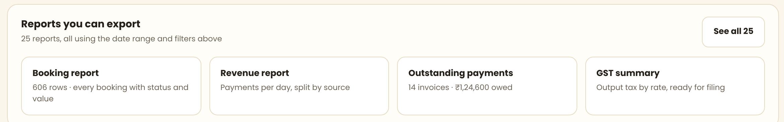
Four shortcuts into the most used reports, carrying the current filters
Four cards linking to the most used reports, and a See all link to the library. Clicking one opens that report with the date range and location from this screen already applied — the admin should never have to set the same filters twice.

4. Screen 2 — A Single Report
Every one of the reports in the library opens on this same layout. The example used here is the Booking report; only the filters, the summary figures, the chart and the columns change from one report to another. Build this screen once and drive it from a report definition.
The single report screen, using the Booking report as the example

4.1 The Top Of The Page
- A breadcrumb: Reports & analysis / Report library / Booking report. Each part is a link.
- The report name, and under it one plain sentence stating what the result covers and how big it is: "Every booking made between 29 September and 12 October 2026 — 247 bookings, worth ₹4,86,300." Rewrite this sentence every time the report is run.
- Four buttons on the right: Save as favourite (a toggle, the star fills when on), Email weekly (opens the schedule dialog described in Section 12), PDF, and Export to Excel as the dark primary button.

4.2 The Filter Bar
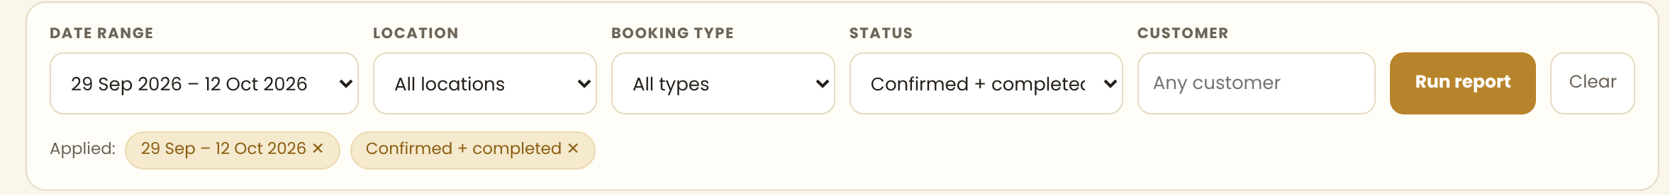
Filters on top, and the ones currently applied shown as chips underneath
Filter | Behaviour
Date range | The same control as the overview, defaulting to the last 30 days. Mandatory — a report never runs without one
Location | All locations, or one. Hidden when there is only one location
Booking type | All types, Desk, Cabin, Meeting room, Day pass, Event space. Multi-select
Status | Confirmed + completed by default. Also: All, Confirmed, Completed, Cancelled, No-show. This default matters: a report of bookings should not silently include cancelled ones
Customer | A type-ahead on customer name, company name, phone and email. Empty means any customer
Run report | Runs the query. Nothing reloads until this is pressed, so the admin can change several filters at once
Clear | Resets every filter to its default and runs again
Applied chips | Every filter that is not at its default appears as a chip with a cross. Removing a chip re-runs the report immediately. This is how the admin knows what they are looking at — never leave a filter active without a chip
NOTE: Each report defines its own filter set. A revenue report has payment mode instead of booking type; a customer report has KYC status. The filter bar is one component driven by that definition, not six copies of the same markup.

4.3 The Summary Figures
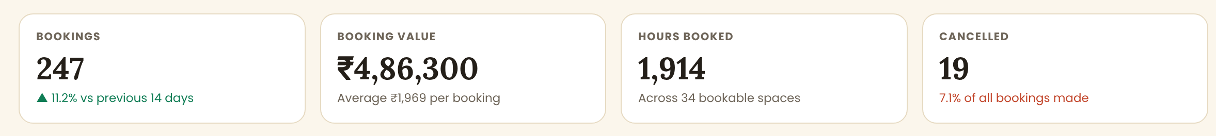
Four figures that describe the whole result, not the visible page
Figure | What it is
Bookings | How many rows the filters matched, in total, with the change against the previous period of the same length
Booking value | The total value of all matching bookings, and the average per booking underneath
Hours booked | Total hours across all matching bookings. Monthly and open-ended bookings contribute nothing here and show a dash in the table
Cancelled | How many of the bookings made in this period were cancelled, and that number as a percentage of all bookings made
NOTE: These four figures are calculated with their own aggregate query over every matching row. They are NOT the sum of the 50 rows shown in the table. If a developer computes them in the browser from the loaded page, the figures will be wrong the moment there is a second page — this is the most common bug in reporting screens and it must not happen here.

4.4 The Chart Strip
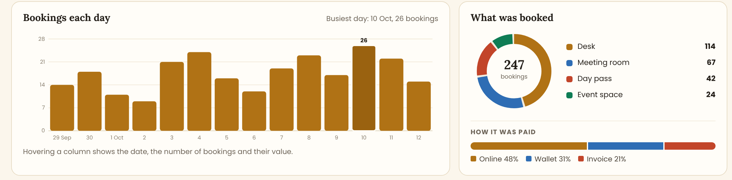
A chart of the result, and a breakdown of what it is made of
- Bookings each day — one column per day in the range, with the busiest day labelled above its column and named in the card header. Hovering a column shows the date, the count and the value.
- What was booked — a doughnut with the four booking types, the total printed in the middle, and a legend listing each type with its count. The legend is part of the chart, not optional.
- How it was paid — a single stacked bar under the doughnut: Online, Wallet, Invoice, with the percentages named beneath it.
- Each report defines its own chart strip. A revenue report shows revenue per day and a split by payment mode; an occupancy report shows a heatmap. Where a report genuinely has no useful chart, show the summary figures only and leave the strip out — do not invent a chart to fill the space.

4.5 The Table
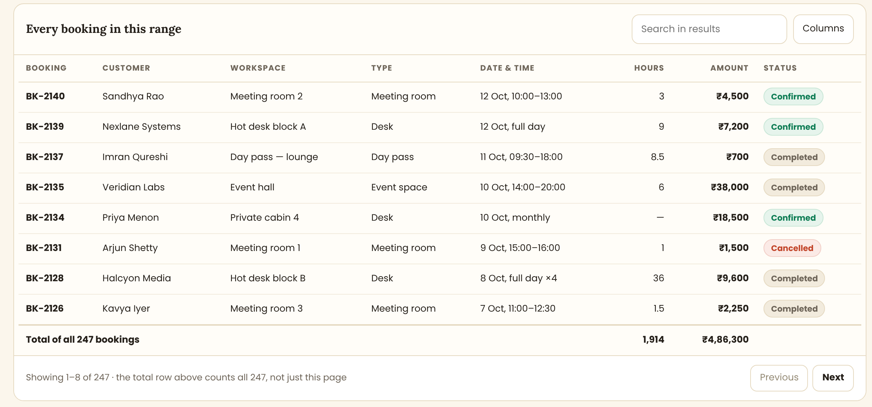
The rows themselves, with a true grand total that covers all 247 bookings
Element | Behaviour
Columns | Booking, Customer, Workspace, Type, Date & time, Hours, Amount, Status. Numbers right-aligned, text left-aligned, always
Search in results | Filters inside the result set only. It does not re-run the query against the whole database
Columns button | Lets the admin tick which columns to show and drag to reorder. The choice is remembered per admin, per report
Sorting | Every column header sorts. Sorting is done by the server across all rows, then the first page is returned — not by sorting the page in the browser
Status pill | Green Confirmed, grey Completed, red Cancelled, amber No-show. The same pill component as the bookings screen
The total row | Separated by a heavier line, labelled "Total of all 247 bookings", and holding the totals for the numeric columns across the entire result
Row click | Opens that booking in a side panel. The report stays behind it with its filters intact
Pagination | 50 rows a page, with a line stating the range shown and repeating that the total row counts everything
NOTE: Write the sentence "the total row above counts all 247, not just this page" into the interface, exactly as shown in the design. Admins have been burnt by spreadsheets that total only the visible rows and they need to be told.

5. Screen 3 — The Report Library
The library replaces the current wall of identical cards. It answers one question: which report do I want, and can I get it without opening five of them.
The report library — favourites, grouped lists, and the schedules

5.1 Search And Categories
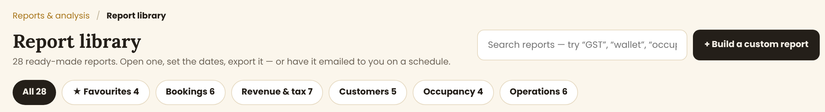
A search box that searches descriptions as well as names, and category chips with counts
- Search matches the report name, its description and its keywords, so typing "GST" finds the GST summary and typing "money" finds Money owed to us. Results filter as the admin types.
- Category chips with live counts: All, Favourites, Bookings, Revenue & tax, Customers, Occupancy, Operations. One is always selected.
- Build a custom report opens the custom report builder. This is a later phase — see open item 5 — but the button must be in the design from day one.

5.2 Favourites
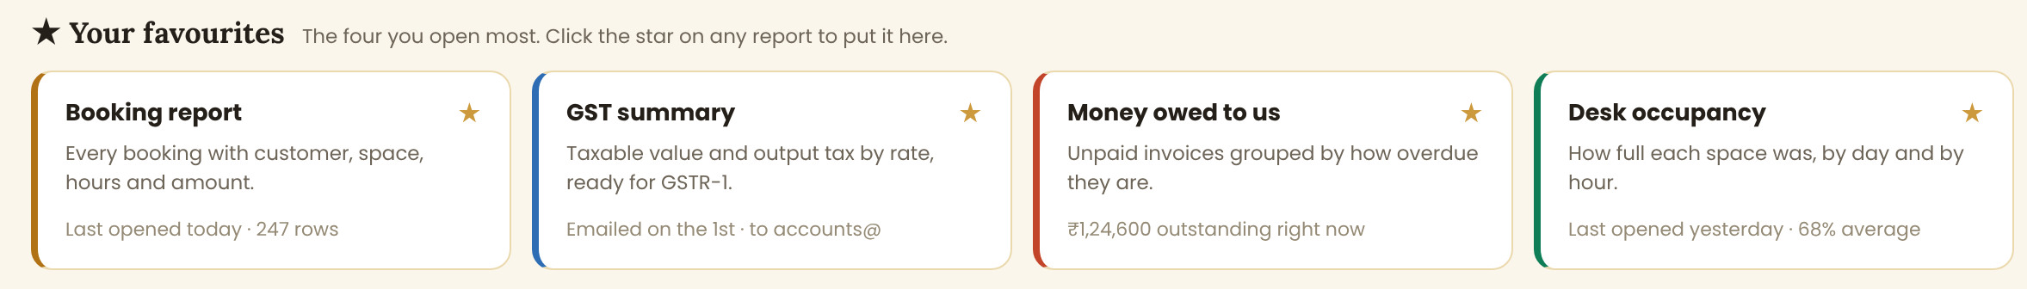
The four most used reports, pinned by the admin, each with a live figure
- Four cards. The admin chooses them with the star on any report; they are per admin, not shared.
- Each card carries the report name, one line saying what it contains, and a live status line — when it was last opened, how many rows it returned, how much is outstanding, or when it is next emailed.
- The coloured left edge is the category colour, so the four cards stay distinguishable at a glance.
- If an admin has starred nothing yet, show the four most opened reports across the whole account and label the section "Most used".

5.3 The Grouped Lists
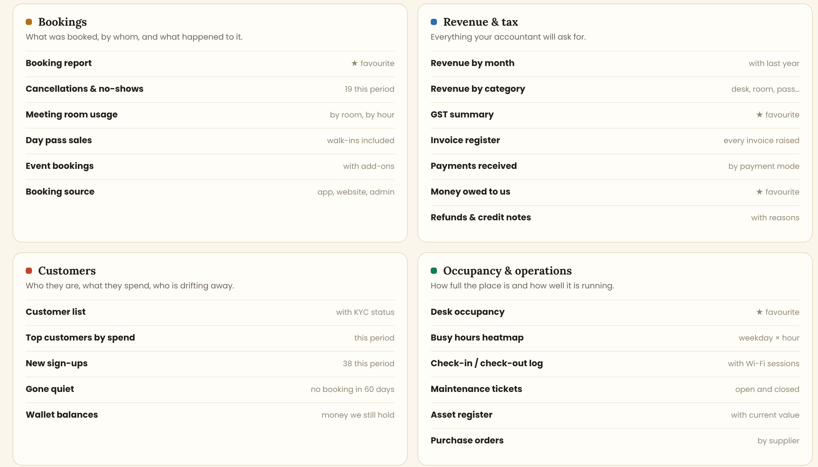
All reports, in four groups, with a one-line hint beside each
- Four cards: Bookings, Revenue & tax, Customers, and Occupancy & operations. Each has a coloured dot matching its category, a heading, and one sentence explaining what the group is for.
- Inside, one row per report: the name on the left, and on the right either a live figure, a hint about the content, or "★ favourite".
- The rows are links. The whole row is clickable, not just the text.
- Reports the admin has no permission to see are not shown at all — they are not greyed out. See Section 13.

5.4 Reports That Email Themselves
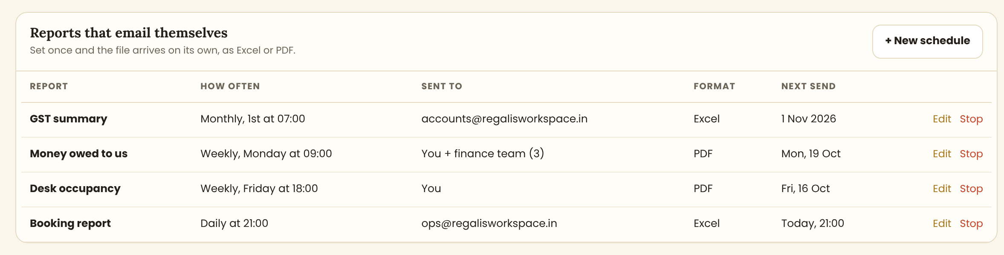
Every active schedule, in one table at the bottom of the library
Column | Content
Report | The report being sent, as a link to it
How often | Daily / Weekly on <day> / Monthly on the <n>th, and the time, in IST
Sent to | The recipients. More than three are shown as "You + finance team (3)" with the full list on hover
Format | Excel or PDF
Next send | The next run as a friendly date: "Today, 21:00", "Mon, 19 Oct", "1 Nov 2026"
Edit / Stop | Edit reopens the schedule dialog. Stop asks for confirmation and then disables it. A stopped schedule is kept, not deleted, so it can be turned back on
NOTE: If the last run of a schedule failed, show a red "Last run failed" line under that row with the reason, and keep showing it until the next run succeeds. A silent failed schedule is worse than no schedule.

6. The Report Catalogue
Twenty-eight reports in four groups. Each one is a row in a report definition table in the database, not a separate page in the code.

6.1 Bookings
Report | What it contains
Booking report | Every booking with customer, workspace, type, date and time, hours, amount and status
Cancellations & no-shows | Cancelled and no-show bookings with the reason, who cancelled, how much notice was given, and the refund if any
Meeting room usage | Hours booked per room, per day and per hour, with the share of available hours used
Day pass sales | Day passes sold, including walk-ins, with the price charged and the payment mode
Event bookings | Event space bookings with add-ons, headcount and the final invoiced amount
Booking source | Bookings split by where they came from: the app, the website, an admin, or a walk-in

6.2 Revenue & Tax
Report | What it contains
Revenue by month | Revenue per month for the selected range, with the same months last year beside them
Revenue by category | Revenue split by cabins, desks, meeting rooms, passes and services
GST summary | Taxable value and output tax grouped by rate (0%, 5%, 12%, 18%), split into CGST, SGST and IGST, in the shape GSTR-1 needs
Invoice register | Every invoice raised, with the customer, GSTIN, taxable value, tax, total, due date and paid status
Payments received | Every payment with date, customer, invoice, mode (UPI, card, bank transfer, cash, wallet) and reference
Money owed to us | Unpaid and part-paid invoices grouped into not due, 1–30, 31–60 and over 60 days late, with contact details
Refunds & credit notes | Every refund and credit note with the reason, who approved it and the original invoice

6.3 Customers
Report | What it contains
Customer list | Every customer with type, company, GSTIN, KYC status, join date and lifetime spend
Top customers by spend | Customers ranked by revenue in the period, with bookings and average booking value
New sign-ups | Customers who registered in the period, with the source and whether they have booked yet
Gone quiet | Customers with no booking in the last 60 days who had booked before, with the date they last came in
Wallet balances | Money Regalis is still holding: balance per customer, last top-up and last spend

6.4 Occupancy & Operations
Report | What it contains
Desk occupancy | Occupancy per space, per day, as hours used out of hours available
Busy hours heatmap | Weekday against hour, with the average occupancy of each slot
Check-in / check-out log | Who came in, when they came in and left, and the matching Wi-Fi session if there is one
Maintenance tickets | Tickets raised, with the asset, priority, who it was assigned to, when it was closed and how long it took
Asset register | Every asset with location, purchase date, cost, depreciation and current value
Purchase orders | Purchase orders by supplier, with the value, the status and what was delivered
NOTE: A report definition holds: the key, the name, the description, the category, the keywords for search, the filters it offers, the summary figures, the chart strip, the columns, the default sort, and the permission required to see it. Adding a report should be adding a row and a query — not a new screen.

7. Flow Charts
Five flows. Read the shapes this way: a black oval starts the flow, a cream box is something a person does, a diamond is a decision, a blue box is something the system does on its own, a green box is a successful end, and a red box is a failure or a blocked path.

7.1 Opening The Overview Page
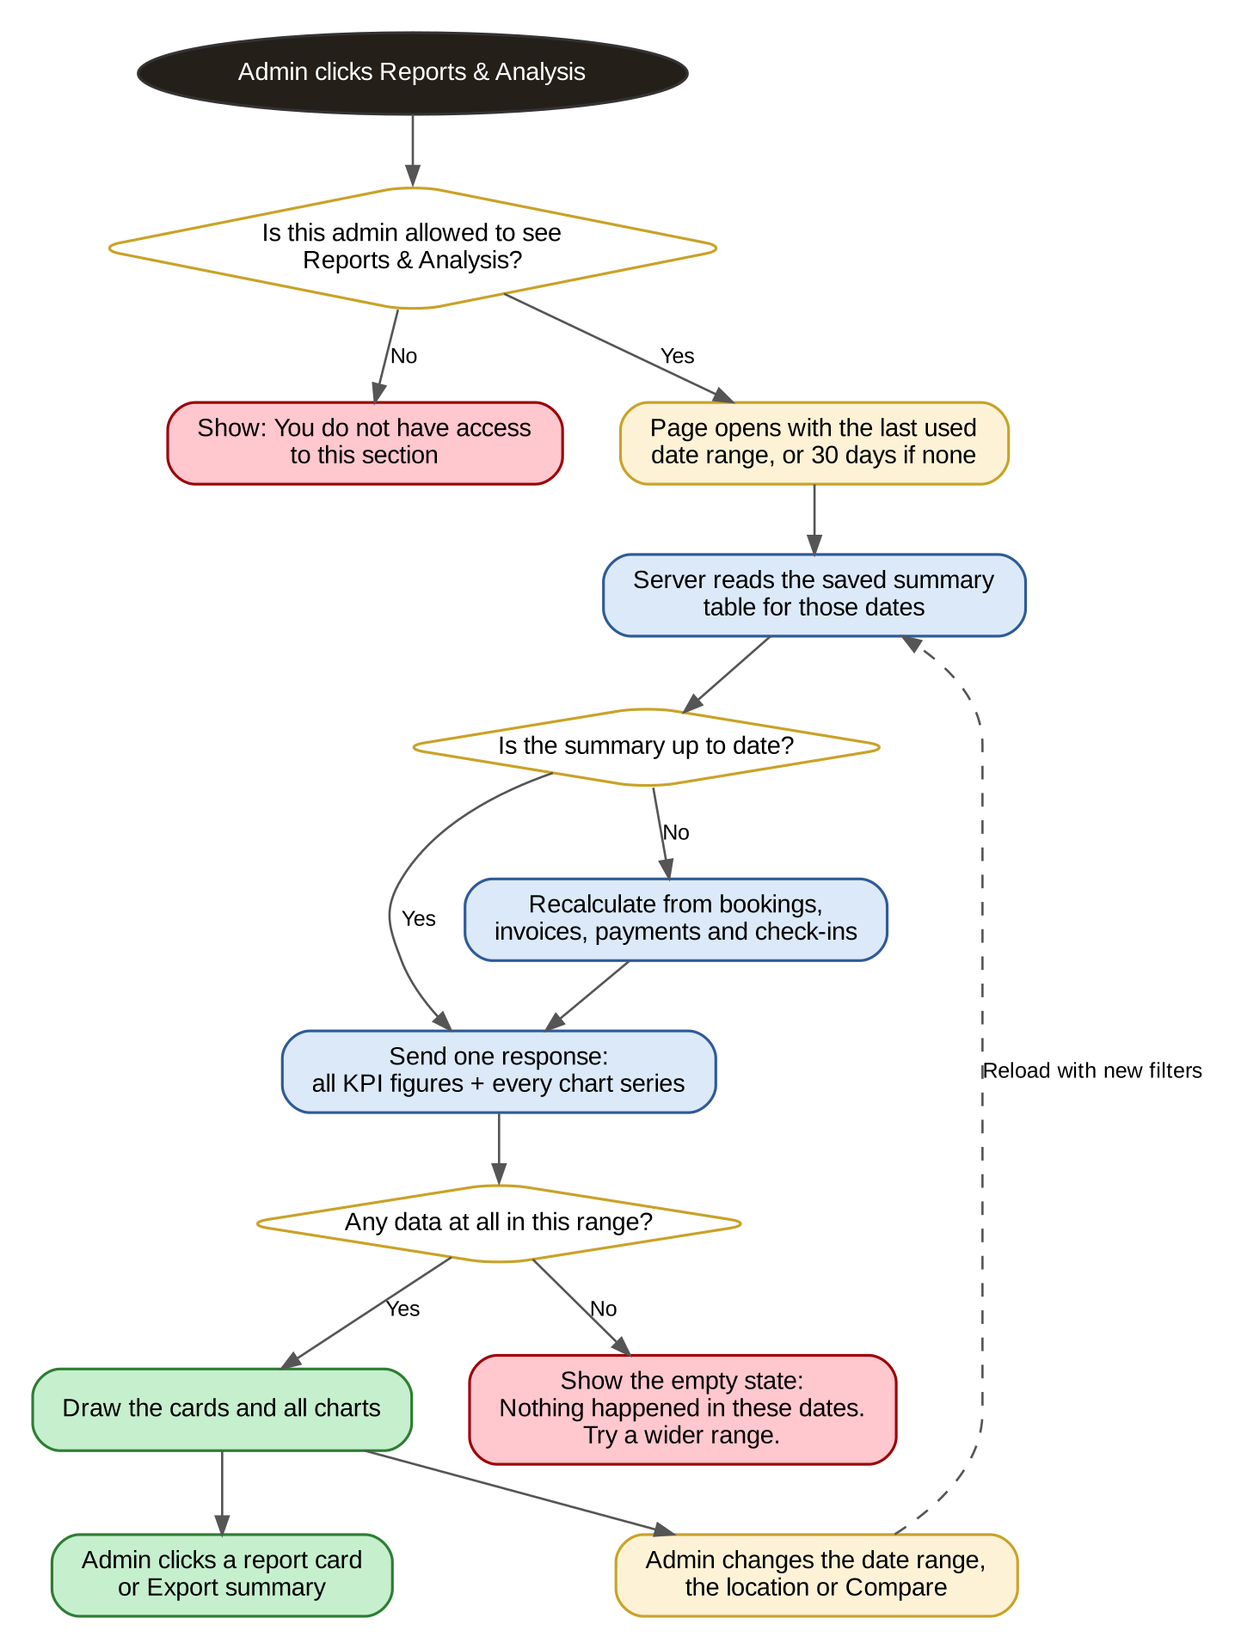
Flow 1 — what happens between clicking Reports & Analysis and seeing the charts
- Permission is checked before anything is loaded, not after.
- The page opens on the range the admin last used, so returning to it does not mean setting the filters again.
- Figures are read from a pre-calculated summary table when it is current; only today is calculated live. Section 9.1 covers this.
- The whole screen is one response. Do not make one request per chart — twelve requests for one page is the slowest possible way to build it.

7.2 Running A Report
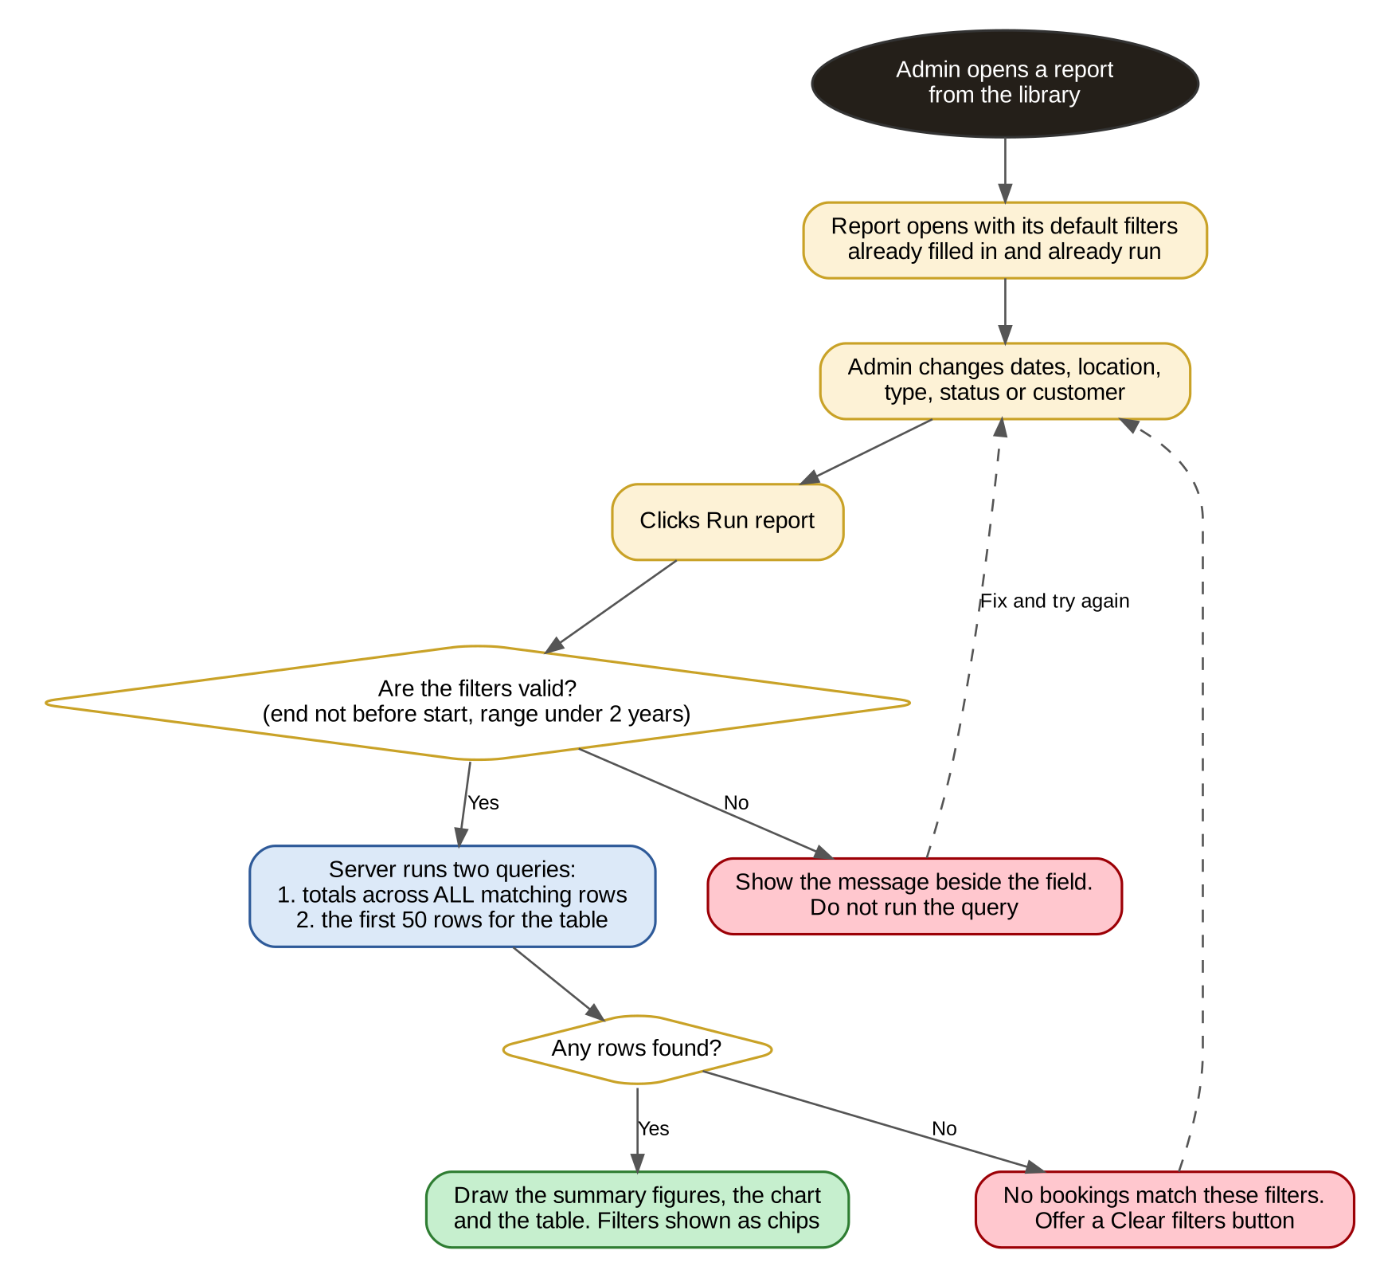
Flow 2 — from opening a report to seeing the result
- A report opens already run on its default filters. The admin should never land on an empty screen with a Run button.
- Changing filters does nothing until Run report is pressed, so several filters can be changed at once — except removing a chip, which re-runs immediately.
- Two queries always run: one for the totals across every matching row, one for the first page of rows. Never one.
- Invalid filters are caught before the query, with the message next to the field that is wrong.

7.3 Exporting
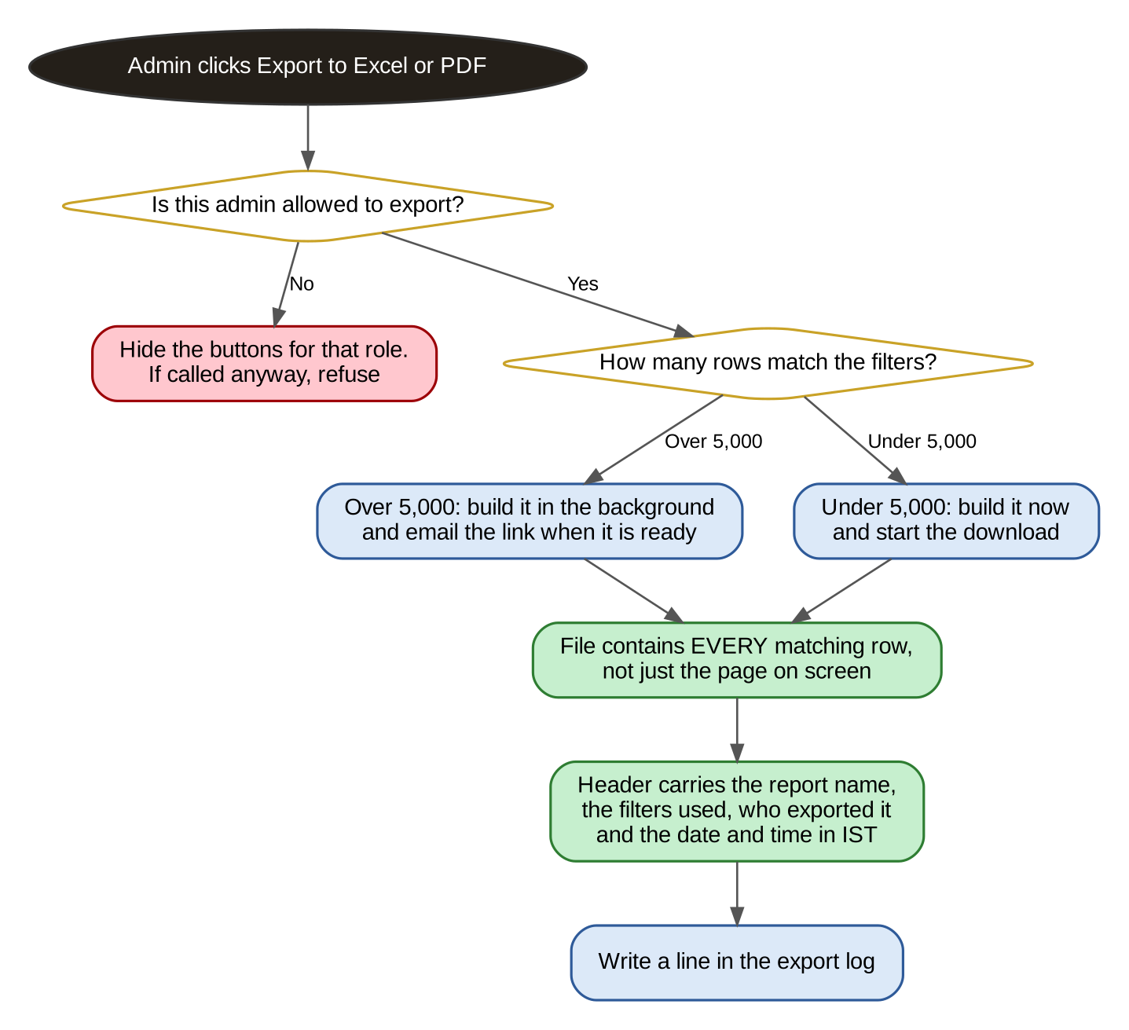
Flow 3 — Excel and PDF exports
- Under 5,000 rows the file is built immediately and downloaded. Above that it is built in the background and emailed, so the browser is never left hanging.
- The file always contains every matching row, never only the page on screen.
- Every export is logged: who, which report, which filters, how many rows, and when. Exports contain customer contact details, so there must be a record of who took one.

7.4 A Report That Emails Itself
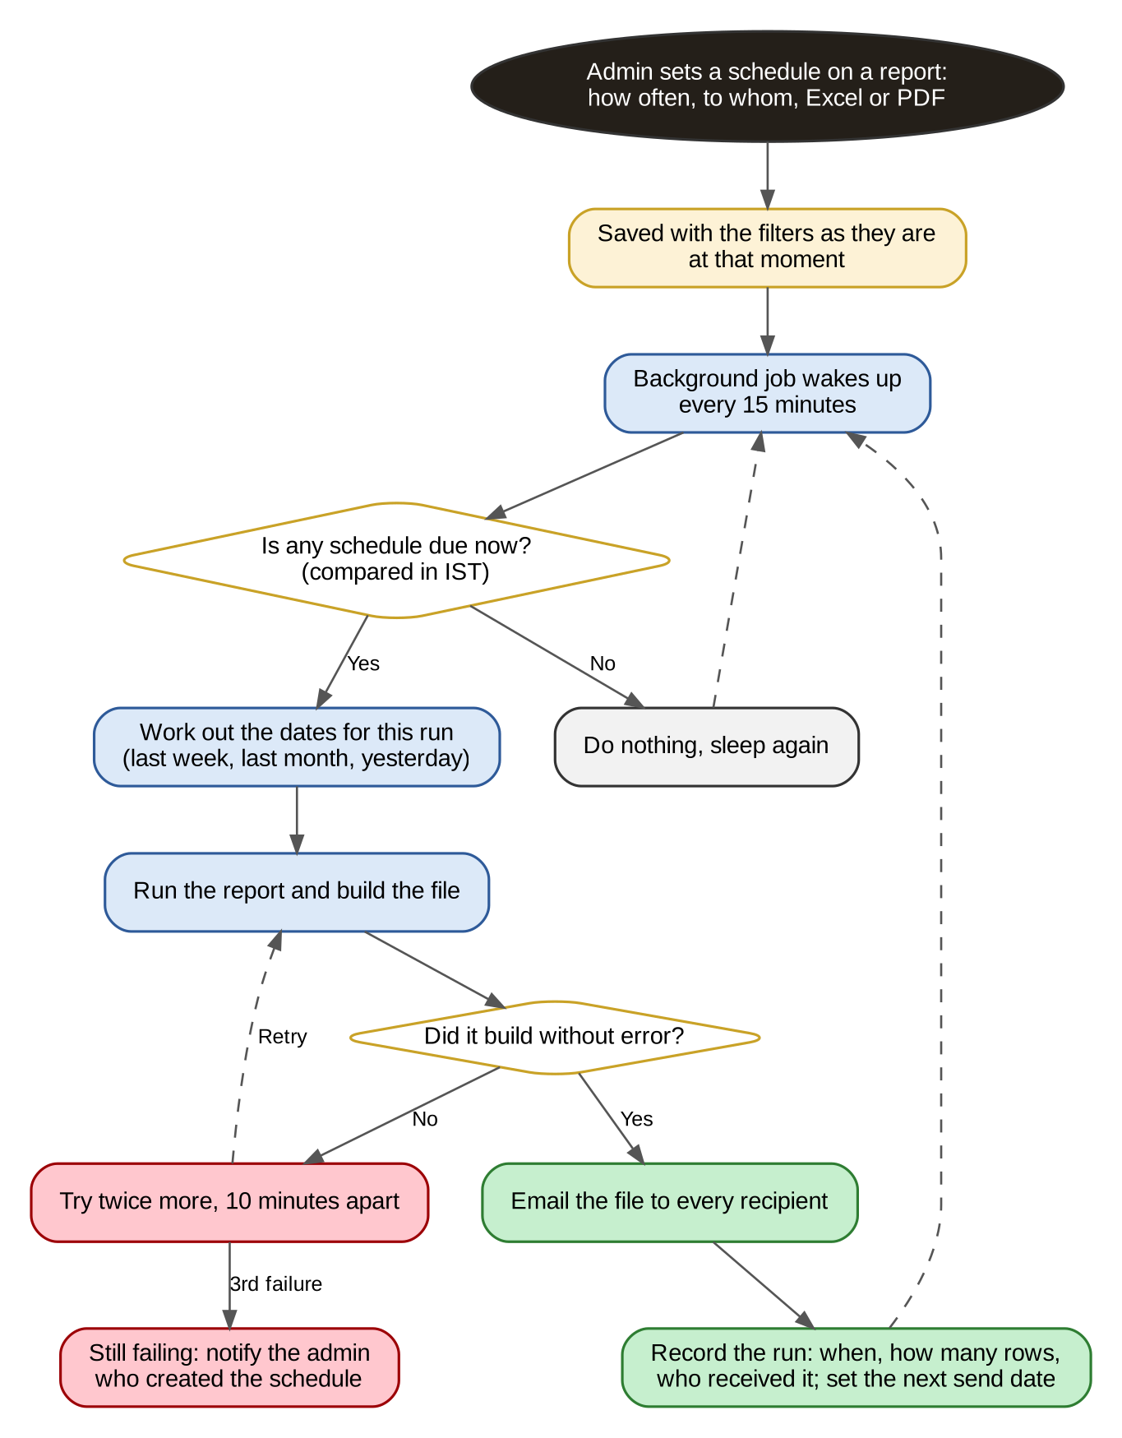
Flow 4 — the scheduled report job
- The schedule stores the filters as they were when it was created, except the dates, which move with each run: a weekly report sent on Monday covers the previous week.
- A background job runs every 15 minutes and compares against Indian Standard Time. Do not compare in UTC — a monthly report would go out on the wrong day.
- A failed build is retried twice, ten minutes apart, and then reported to the admin who created the schedule.
- Every run is recorded with the row count and the recipients.

7.5 How A Figure Gets To The Screen
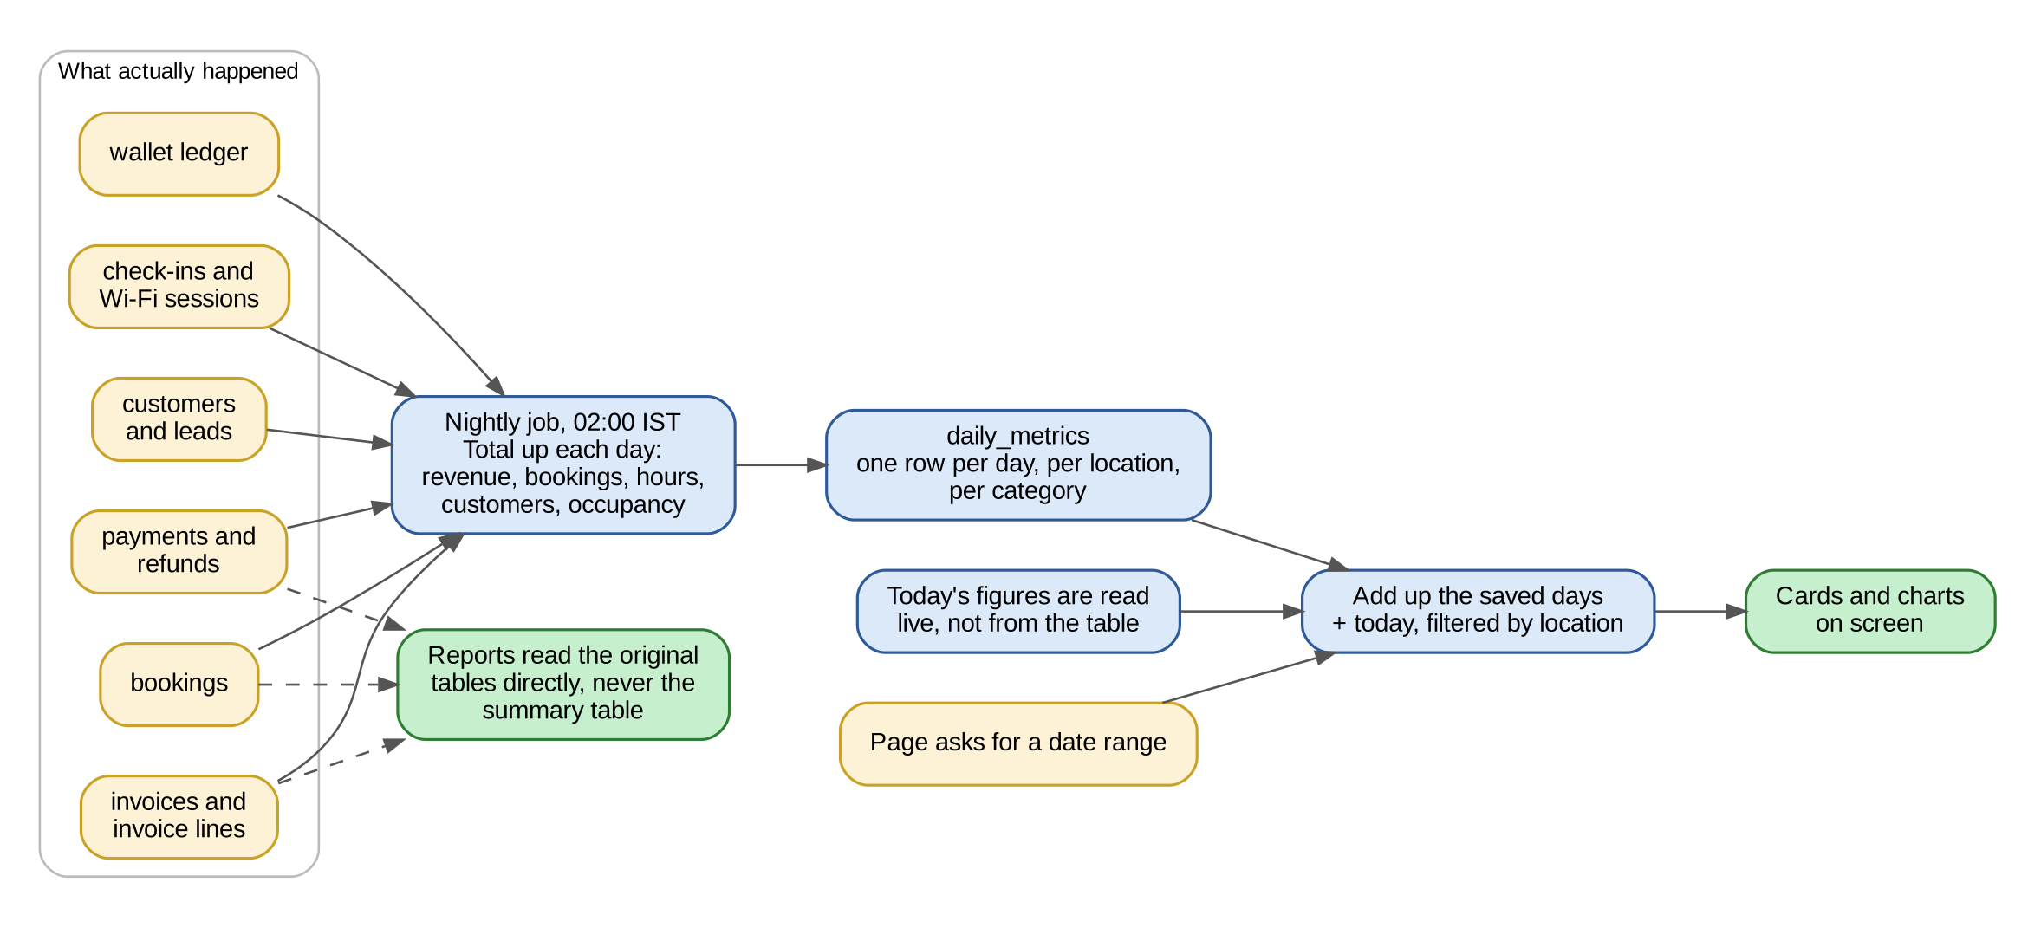
Flow 5 — from the operational tables to a number on a card
- A nightly job totals each completed day into a summary table, one row per day, per location, per category.
- The overview page adds up those saved days and calculates only today live. This is what makes the page load in under two seconds.
- Reports never read the summary table. They always read the original tables, because a report must be exact and must be able to show individual rows.
- If the nightly job has not run, the page must still be correct — it falls back to calculating the range live and logs a warning. It must never show a stale or a partial figure as if it were current.

8. The Rules Every Number Must Follow
This is the most important section in the document. Most reporting bugs are not interface bugs; they are a figure that is quietly wrong. These rules are not negotiable.

8.1 Totals Are Calculated On The Server, Across All Rows
NOTE: Never calculate a total, a count, an average or a percentage from the rows loaded into the browser. Every summary figure and every chart series comes from its own aggregate query (SUM, COUNT, AVG with GROUP BY) over all rows matching the filters. The table pagination and the totals are two separate queries over the same filter set.

8.2 Revenue Means Money Received
- Revenue on the overview and in the revenue reports means payments actually received in the period, net of refunds. It is cash, in IST.
- Invoiced is a different figure and belongs in the invoice register and the GST summary, where it must be labelled "invoiced", never "revenue".
- A payment received in October against a September invoice counts in October.
- A refund is subtracted on the day it was paid out, not on the day of the original booking.
- Wallet top-ups are not revenue. Revenue is recognised when the wallet is spent on a booking. Counting both would double the figure.
NOTE: Confirm this with the client before building — open item 1. Some businesses want the dashboard to show invoiced value rather than collected cash. Whichever is chosen, the word on the screen must match the rule behind it.

8.3 Time, Dates And The Financial Year
- Every date and time on these screens is Indian Standard Time. Store in UTC, convert at the edge, and never let a report group by a UTC day.
- A day runs 00:00 to 23:59:59 IST. A booking is counted on the day it starts.
- FY means 1 April to 31 March. "This year" on a chart axis means the financial year, not the calendar year, unless the label says otherwise.
- A date range is inclusive at both ends. 1 Sep to 30 Sep is 30 days, not 29.
- The previous period is the same number of days immediately before the start of the current one — not the same dates last month.

8.4 Money
- Store money in paise as an integer. Never in a floating point number.
- Display in the Indian grouping: ₹2,70,900, not ₹270,900.
- Round only at the point of display. All intermediate maths uses full precision.
- Amounts on the dashboard are inclusive of GST unless the card says otherwise. The GST summary and the invoice register show taxable value and tax separately.
- Where a column of money is totalled, the total must equal the sum of the unrounded values, rounded once. Rounding each row and then adding them will be off by a few rupees and an accountant will notice.

8.5 What Is Counted And What Is Not
Case | The rule
Cancelled bookings | Excluded from booking counts, revenue and occupancy. Counted in the Cancelled figure and in the cancellations report
No-shows | Counted as a booking and as revenue if the money was kept. Flagged separately so they can be filtered out
Free and complimentary bookings | Counted in bookings and occupancy, with zero revenue. Never hidden
Internal and staff bookings | Excluded from every report by default, with a filter to include them
Blocked or under maintenance | Removed from available hours in the occupancy calculation, so a closed room does not look empty
Part payments | Counted on the date and for the amount actually received. The invoice stays in Money owed for the remainder
Multi-day and monthly bookings | Revenue spread evenly across the days covered, so one monthly invoice does not create a spike on one day
Deleted records | Nothing is ever hard deleted. Reports exclude soft-deleted rows but the rows remain

8.6 Percentages And Comparisons
- A percentage change is (now − before) ÷ before × 100, rounded to one decimal.
- If the previous value is zero, show "no comparison", never infinity, never 100%.
- If the previous value is negative, show the absolute change in rupees instead of a percentage.
- Shares of a total are rounded so that they add to exactly 100. Give the rounding remainder to the largest share.
- Any figure that cannot be calculated shows a dash, never a zero. Zero and unknown are different things.

9. Where Every Number Comes From
Reports & Analysis reads from tables that already exist. It adds four small tables of its own, and one summary table that it fills itself.

9.1 The Tables It Reads
Table | What this module takes from it
bookings | Count, hours, value, type, workspace, customer, status, source, start and end
invoices + invoice_lines | Invoiced value, taxable value, tax by rate, due date, paid status, category of what was sold
payments | Money received: date, amount, mode, customer, invoice
refunds / credit_notes | Money paid back: date, amount, reason, original invoice
wallet_ledger | Top-ups, spends and balances per customer
customers | Registration date, type, company, GSTIN, KYC status, source
workspaces | The list of bookable spaces, their capacity, their opening hours and any blocked periods
check_ins / wifi_sessions | Actual presence in the building, for the check-in log and for comparing booked against used
maintenance_tickets, assets, purchase_orders | The operations reports

9.2 The Tables It Adds
Table | Columns | Why
daily_metrics | date, location_id, category, revenue_paise, bookings_count, hours_booked, hours_available, new_customers, cancelled_count | The pre-calculated summary that makes the overview fast. One row per day, per location, per category. Filled by a nightly job at 02:00 IST and re-buildable for any date
report_favourites | user_id, report_key, created_at | Favourites are per admin
report_preferences | user_id, report_key, filters_json, columns_json, sort_json, updated_at | Remembers the last filters and column choice per admin, per report
report_schedules | report_key, filters_json, frequency, day_of_week, day_of_month, time_ist, recipients, format, created_by, is_active, last_run_at, last_run_status, next_run_at | The scheduled emails
report_exports | user_id, report_key, filters_json, row_count, format, created_at | The export log. Append only

9.3 The Formulas
Figure | How it is calculated
Revenue | SUM(payments.amount) − SUM(refunds.amount), both by their own date, in IST, within the range
Bookings | COUNT(bookings) where start_date is in the range and status is not cancelled and is_internal is false
New customers | COUNT(customers) where registered_at is in the range
Occupancy % | SUM(hours booked) ÷ SUM(hours available) × 100. Hours available = capacity × open hours, minus any hours the space was blocked or under maintenance
Average booking value | Total booking value ÷ number of bookings. Shown to the nearest rupee
Cancellation rate | Bookings cancelled in the range ÷ bookings MADE in the range × 100. Note the denominator: bookings made, not bookings starting
Ageing bucket | Today minus invoice.due_date, on the unpaid balance of the invoice, not its full value
Heatmap cell | Average occupancy of that weekday and hour across every matching weekday in the range
Previous period | The same number of days immediately before the start date, with the identical filters re-applied

9.4 The API
Endpoint | What it returns
GET /api/admin/reports/overview | Everything screen 1 needs, in one response: the four cards with their comparisons and sparklines, and every chart series. Takes from, to, location_id and compare
GET /api/admin/reports/definitions | The report catalogue the library is drawn from, filtered to what this admin may see
POST /api/admin/reports/:key/run | Runs a report. Takes the filters, the page, the page size and the sort. Returns the summary figures, the chart series, the page of rows and the total row count — in that one response
POST /api/admin/reports/:key/export | Starts an export. Returns the file directly, or a job id when the result is over 5,000 rows
GET/POST/DELETE /api/admin/reports/favourites | Favourites for the signed-in admin
GET/POST/PATCH/DELETE /api/admin/reports/schedules | The scheduled emails
NOTE: Every one of these endpoints takes the filters as parameters and applies them inside the SQL. Never fetch rows and filter them in the application layer, and never send more rows to the browser than the page being shown.

10. The Charts Themselves
The charts are the point of the redesign, so their rules are fixed here rather than left to the developer or to a charting library default.

10.1 The Colours
Five colours, used in this fixed order, for anything that has an identity — a category, a booking type, a payment mode. They have been checked so that neighbouring pairs stay apart for colour-blind readers.
Order | Name | Hex | Typically used for
1 | Gold | #B07215 | The first series, and all single-series charts
2 | Blue | #2E6DB4 | The second series
3 | Clay | #C2452A | The third series
4 | Green | #0F7D55 | The fourth series
5 | Plum | #9B3D8C | The fifth series
- Never cycle the palette. A sixth category is folded into "Other", not given a sixth colour.
- Colour follows the thing, not its rank. Meeting rooms are blue whether they are second or fourth in the sort order, and a filter that removes a category must not repaint the others.
- For the occupancy heatmap use one colour in five steps, light to dark: #F7EDD6, #EAD5A4, #D9B468, #C2912C, #9A6A12. Never a rainbow, never red-to-green.
- Red is reserved for bad (cancelled, overdue, down) and green for good (confirmed, paid, up). Do not use either as an ordinary series colour in a chart that also shows status.
- Text is never coloured with the series colour. Labels, values and legends stay in the normal ink colours; the coloured swatch beside them carries the identity.

10.2 Which Chart For What
The question | The chart
How did this change over time? | Line, or line with a filled area when there is only one series
How does this split into parts, over time? | Stacked columns, with the total printed above each column
Which is biggest? | Horizontal bars, sorted, with the value printed at the end of each
What share of the whole? | A doughnut, but only when there are five slices or fewer. Six or more becomes bars
When is it busy? | A heatmap of weekday against hour
One number that matters | No chart. A card with the figure and its comparison
NOTE: Never build a chart with two different y-axes. If two measures have different scales, use two charts stacked on top of each other with a shared x-axis. This is the single most common charting mistake and it makes any trend look like whatever the author wanted it to look like.

10.3 How The Charts Behave
- Every chart has a hover state. Line and area charts get a vertical crosshair and a tooltip that follows the cursor anywhere on the plot; bars, cells and doughnut slices get a tooltip on the mark itself.
- A tooltip always names the thing, the period and the value, with the units — "6 Oct 2026, ₹31,500, 24 bookings".
- Two or more series always have a legend, and where there are four or fewer the series are also labelled directly on the chart, so nothing depends on colour alone.
- Axes and gridlines are light grey and recessive. Four gridlines at most. A value axis always starts at zero.
- Not every point gets a label — only the highest, the lowest, the latest, or the one being hovered.
- Every chart has a "View as table" option for an admin who wants the numbers, and for screen readers.
- Charts must redraw on resize and must be legible at 1280px wide. They are not required to work on a phone — this is an admin screen — but nothing may overflow or be cut off.

10.4 Loading, And Not Jumping About
- While data is loading, show a skeleton the same size as the chart that is coming. Do not show a spinner that is then replaced by content of a different height.
- Charts animate in once, quickly (under 400ms). They do not re-animate when a tooltip moves or when the window resizes.
- If one chart fails to load, that card shows "Could not load this chart — Retry" and the rest of the page still works.

11. Exports
Every report exports to Excel and to PDF. The overview screen exports to PDF only.

11.1 Excel
- One sheet of data, with the column headers in the first row, frozen, and a filter applied to the header row.
- Above the data, four lines: the report name, the filters used in plain English, who exported it, and the date and time in IST.
- Money is written as a number with a rupee currency format, not as text. Dates are written as dates. An accountant must be able to pivot the sheet without cleaning it first.
- The grand total row is included at the bottom and is formatted bold.
- The file is named report-name_from-date_to-date.xlsx, for example booking-report_2026-09-29_2026-10-12.xlsx.

11.2 PDF
- Landscape, A4, with the Regalis letterhead, the report name, the filters and the date and time of export.
- The summary figures and the chart are included at the top, then the table.
- Page numbers as "Page 2 of 7", and the column headers repeated on every page.
- For results over 500 rows, the PDF contains the summary and the chart and the first 500 rows, with a line saying so and pointing to the Excel export.

11.3 Rules That Apply To Both
NOTE: An export always contains every row that matched the filters, never only the page on screen, and the figures in the export must equal the figures on the screen to the rupee. If they differ, the screen is being calculated in the browser and Section 8.1 has been broken.
- Over 5,000 rows, the file is built in the background and emailed as a link that expires in seven days.
- Every export is written to the export log with the admin, the report, the filters, the row count and the time.
- An admin without the export permission does not see the buttons, and the endpoint refuses the request even if it is called directly.

12. Reports That Email Themselves
Any report can be put on a schedule from its own page or from the library.

12.1 The Schedule Dialog
Field | Behaviour
How often | Daily, Weekly or Monthly. Weekly asks for the day; Monthly asks for the date, with "last day of the month" as an option
Time | A time in IST, in 30-minute steps
Send to | One or more email addresses. Defaults to the admin creating it. Any address may be used, including people who are not Regalis admins — which is why the export permission is required to create a schedule
Format | Excel or PDF
Which dates | Rolling, and it moves with each run: a weekly report covers the previous week, a monthly one the previous month, a daily one yesterday. The dates are not frozen
Only if there is data | A checkbox. When ticked, a run with no rows sends nothing instead of sending an empty file

12.2 How The Job Runs
- A background job wakes every 15 minutes and compares the current IST time against every active schedule.
- It works out the date range for this run, runs the report with the stored filters, builds the file and emails it.
- A failure is retried twice, ten minutes apart. After the third failure it notifies the admin who created the schedule and marks the row as failed in the library.
- Every run is recorded with the time, the row count, the recipients and the outcome.
- If a schedule has been failing for a week, disable it automatically and tell the admin why.
NOTE: The comparison must be done in IST. A monthly report scheduled for the 1st at 07:00 will go out on the last day of the previous month if the job compares in UTC — and a GST report sent on the wrong day is a real problem.

13. Who Can See What
Reporting exposes money and customer contact details in one place, so it needs its own permissions rather than riding on the general admin role.
Permission | What it allows
reports.view | Open Reports & Analysis and the library, and run the reports in the Bookings and Occupancy groups
reports.finance | Also see the Revenue & tax group, the money figures on the overview, and the Money owed report
reports.customers | Also see the Customers group, which contains names, phone numbers and email addresses
reports.export | Download Excel and PDF, and create schedules
reports.manage | Edit or stop any schedule, including those created by another admin
- An admin who does not have a permission does not see those reports in the library at all. Do not show them greyed out — the list of reports is itself information.
- Without reports.finance, the Revenue card and the Money owed card on the overview are hidden and the layout closes up around them. The page must not show an empty gap or a locked card.
- Every permission is checked again on the server for every request. Hiding a button is presentation, not security.
- Front desk staff should get reports.view only. The finance team gets view, finance and export. The owner gets everything.
NOTE: Confirm the role mapping with the client before building — open item 6. The permissions themselves can be built now; who holds them is a configuration decision.

14. Performance And Technical Notes

14.1 Targets
Screen | Target
Overview, 30-day range | Under 2 seconds, in one request
Overview, financial year range | Under 3 seconds. This is why daily_metrics exists
A report, first page | Under 2 seconds for up to 100,000 matching rows
An Excel export of 5,000 rows | Under 10 seconds, downloaded directly
Anything larger | Built in the background, with the admin told so immediately

14.2 How To Hit Them
- The nightly rollup. A job at 02:00 IST writes one row per day, per location, per category into daily_metrics. The overview adds those rows up; only today is calculated live. The job must be re-runnable for any past date without creating duplicates.
- Indexes. bookings on (start_date, status, location_id), payments on (paid_at, location_id), invoices on (due_date, paid_status), check_ins on (check_in_at). Without these the reports will be slow from the first month.
- Two queries, not one. The aggregate query and the page query. Do not try to get both from one statement.
- Cache the overview response for five minutes, keyed by admin, date range, location and compare. Clear the cache for today when a payment or booking is recorded.
- Never load everything into memory to export it. Stream the rows into the file in batches.
- Every list is paginated, 50 rows by default, with the page size set by the server, not by the client.

14.3 Build Notes
- The three screens share one layout component, one filter bar component and one table component. The differences between reports live in the report definition, not in duplicated pages.
- Use one charting library for everything and configure the palette from Section 10 once, centrally. Do not set colours chart by chart.
- Chart series come from the API already shaped for the chart. The browser does not aggregate, group or total anything.
- All text in the interface is written as it appears in this document — plain English, no jargon, no "N/A". Where there is nothing to show, write a dash.

15. Empty, Loading And Error States
Situation | What the admin sees
The page is loading | Skeleton cards and chart placeholders the same size as the content that is coming
No data in the selected range | "Nothing happened between these dates." with the range named, and a button that widens it to the last 90 days
A report returns no rows | "No bookings match these filters." with a Clear filters button. The summary figures show zeros, not dashes, because zero is the true answer here
One chart fails | That card alone shows "Could not load this chart" and a Retry link. The rest of the page still works
The whole request fails | One message at the top: "Could not load the reports. Retry." Never a blank page, never a raw error
The nightly rollup has not run | The figures are calculated live, the page is slower, and a quiet line appears for admins only: "Figures calculated live." An alert goes to the technical team. The admin is never shown a stale number
An export is too large | "This export has 42,310 rows. We will email it to you when it is ready." The admin can carry on working
A schedule failed | A red line under that schedule in the library with the reason, until the next successful run
No permission | The reports are not listed, and a direct URL shows "You do not have access to this report"

16. Open Items — Confirm Before Or While Building
# | Assumption made in this document | Needs confirmation
1 | Revenue means money received, net of refunds — not invoiced value | The most important item. Confirm with the client. Every figure on the overview depends on it, and the two numbers can differ by a lot in a month
2 | The financial year is 1 April to 31 March and FY is the default for annual views | Standard in India, but confirm Regalis reports on it
3 | Occupancy is hours booked out of hours available, based on booked time | Whether the client wants actual presence from check-ins instead, which is a different and lower number
4 | Wallet top-ups are not revenue; revenue is recognised when the wallet is spent | Confirm with whoever does the accounts
5 | Build a custom report is in the design but delivered in a later phase | Whether it is needed in the first release, and if so what the builder must allow
6 | Five permissions, with front desk getting view only | The exact role mapping Regalis wants
7 | Opening hours for the occupancy denominator are 9am to 8pm, Monday to Saturday | The real opening hours, and whether they differ by location
8 | Export files over 5,000 rows are emailed as a link that expires in seven days | The threshold and the expiry
9 | daily_metrics is rebuilt nightly at 02:00 IST | Whether there is a quieter window, and how far back a rebuild should go
10 | Reports cover all locations, with a filter for one | Whether an admin should be restricted to their own location

17. Summary For The Developer
If you only read one paragraph of this document, read this one:
NOTE: Replace the Reports & Analysis page with three screens. The first is a dashboard of charts driven by one date-range bar: four headline cards with sparklines and comparisons, revenue over time with a dashed previous period, revenue by category, bookings by type each week, an occupancy heatmap, busiest workspaces, money owed by age, and the top customers. The second is one report page used by all twenty-eight reports, driven by a report definition: filters on top shown as removable chips, three or four summary figures, a chart of the result, then the table with a grand total that covers every matching row and an Excel or PDF export of every matching row. The third is a searchable library, grouped into Bookings, Revenue & tax, Customers and Occupancy & operations, with per-admin favourites and a table of reports that email themselves on a schedule. Every total, count, average and percentage is calculated on the server across all matching rows — never from the page loaded in the browser. Revenue means money received net of refunds, every date is Indian Standard Time, the financial year runs April to March, money is stored in paise and shown in Indian grouping, and cancelled, internal and soft-deleted rows are excluded. The overview is fast because a nightly job totals each day into a summary table and only today is calculated live, while reports always read the original tables. Use the five fixed chart colours in order, one colour per thing rather than per rank, never two y-axes, and always a legend when there is more than one series.
Everything else in this document is detail in support of that paragraph.

